**CONTENT**

|  |  |  |
| --- | --- | --- |
| **S.No.** | **CONTENT** | **PAGE No.** |
| 1. | Abstract | 2 |
| 2. | Project Overview | 3 |
| 3. | System Design | 4 |
| 4. | Input Design | 8 |
| 5. | Output Design | 8 |
| 6. | Menu Level Description | 9 |
| 7. | Process Specification | 10 |
| 8. | Screen Layouts | 11 |
| 9. | Conclusion | 13 |
| 10. | Bibliography | 14 |

**ABSTRACT**

# The Online Course Management System is a comprehensive web-based application designed to streamline and automate the management of courses within educational institutions. Aimed at both students and administrators, this system replaces traditional, manual processes, providing an efficient and user-friendly platform for course registration, management, and tracking. Students can easily browse available courses, register for them, and track their progress, while administrators have a centralized dashboard to manage course offerings, student enrollments, and academic performance.

# The system includes features such as structured course registration forms, real-time tracking of student progress, and automated feedback on assignments and exams. Built using modern web technologies like HTML, CSS, and JavaScript, the platform ensures a responsive, lightweight, and cross-platform compatible experience for all users. The intuitive interface makes navigation seamless for both students and faculty members, enhancing the overall user experience.

# The Online Course Management System offers a scalable solution, enabling easy future enhancements such as integration with payment gateways for course fees, mobile applications for improved access, real-time notifications, and advanced analytics for course and student performance tracking. Additionally, the system ensures data integrity and security, while significantly reducing administrative workload.

# In summary, the Online Course Management System modernizes the course management process, making it more accessible, efficient, and transparent. It enhances communication between students and faculty, simplifies administrative tasks, and supports the digital transformation of educational institutions.

# INTRODUCTION

### PROJECT OVERVIEW

## The Online Course Management System is an advanced, user-friendly web application designed to simplify and automate the entire process of course enrollment, management, and tracking for both students and administrators. This system replaces traditional, paper-based course registration and management methods with a centralized, digital platform, making it more efficient, transparent, and easily accessible for all stakeholders.

## The system allows students to browse and register for courses, access course materials, and track their progress in real-time. Key features include a user-friendly application form where students can submit personal details, select courses, and upload required documents. The system validates the entered data to ensure completeness and accuracy before submission.

## Once registered, students can view the status of their applications, receive course updates, and monitor their progress through a personalized dashboard. On the administrator side, the system provides tools to manage course offerings, student registrations, and track academic performance.

## Built with modern web technologies such as HTML, CSS, and JavaScript, the Online Course Management System is designed to be responsive, lightweight, and cross-platform compatible, ensuring a smooth experience across various devices. The platform’s intuitive interface ensures ease of use for both students and administrators, promoting seamless interaction and minimizing barriers to adoption.

## The workflow of the system begins with student registration and course selection, followed by automatic updates to the course dashboard, where students can track progress, grades, and upcoming tasks. For administrators, the system offers centralized control over course offerings, student enrollments, and reporting, improving efficiency and reducing manual administrative tasks.

## 2. SYSTEM DESIGN

### 2.1 INTRODUCTION

System design is the process of defining the architecture, components, modules, interfaces, and data structures that collectively fulfill the specified requirements of a software system. It represents the transition from understanding what a system needs to do (as identified in system analysis) to figuring out how to achieve those requirements in a structured and efficient manner. While system analysis answers the “what is” question, system design addresses the “how to” aspect of building or improving a system.

This phase plays a critical role in shaping the success of the project. It involves not only outlining technical solutions but also ensuring that these solutions align with the operational and strategic goals of the organization. System design takes the recommendations from the feasibility study and converts them into a comprehensive blueprint for development, laying the groundwork for the implementation phase.

Before diving into system design, careful planning is essential. It is important to conduct a thorough analysis of the existing system—understanding its limitations, inefficiencies, and pain points—to identify how the new or upgraded system can bring about measurable improvements. This involves evaluating how the integration of computing technologies can enhance overall performance, reduce manual effort, and streamline workflows.

The significance of system design lies in its impact on quality. Design is where the foundation for high-quality software is built. A well-crafted design not only meets user requirements but also ensures maintainability, scalability, security, and efficiency of the system. It acts as a communication bridge between the end-users and the developers by transforming user-oriented documentation into technical specifications that can be interpreted and implemented by programmers, database administrators, and system architects.

Moreover, system design is both a technical and creative endeavor. It demands a blend of analytical thinking, problem-solving, and innovation to architect a solution that is technically feasible, economically viable, and user-friendly. It also includes considering user interfaces, data flows, control logic, and hardware-software integration, all of which contribute to a system that is robust, adaptable, and efficient in meeting its intended purpose.

In summary, system design is not just a step in the development cycle—it is the foundation of a successful and sustainable software product. A strong design ensures that the final system is reliable, efficient, and tailored to meet user expectations and institutional objectives.

### 2.2 INPUT DESIGN

1. **User (Student):**
   * **Course Registration Form:**
     + **Full Name:** Student's full name (text input).
     + **Email:** Student's email address (email input).
     + **Phone Number:** 10-digit contact number (numeric input).
     + **Course/Department:** The department or course the student is enrolling in (dropdown/text input).
     + **Gender:** Student's gender (dropdown).
     + **Date of Birth:** Student's date of birth (date picker).
   * **Validation:**
     + All fields are mandatory.
     + Phone number must be exactly 10 digits.
     + Email must follow a valid email format.
     + Gender and Course/Department must be selected from the dropdown.

### 2.3 OUTPUT DESIGN

### Student Outputs:

### Registration Confirmation:

### Popup: On successful submission, a popup appears: “Registration successful.”

### Redirection: The user is redirected to a confirmation page or remains on the dashboard displaying their registration status.

### Application Status:

### After admin review, the status of the application is displayed as:

### Pending

### Approved

### Rejected

### Error Feedback:

### If required fields are missing or invalid, error messages are shown next to specific fields.

### Form submission is prevented until corrections are made.

### Administrator Outputs:

### Course Registration Review:

### Displays a real-time list of all registrations with:

### Student Name

### Course/Department

### Gender

### Application Status (Pending/Approved/Rejected)

### Action buttons (Approve/Reject)

### Dashboard Overview:

### Displays metrics such as:

### Total Number of Applications

### Number of Applications Approved

### **Number of Applications Pending/Rejected

### Course Management:

### Displays all active course registrations with details such as:

### Course Title

### Student's Information

### Registration Status

### Action buttons (Edit/Cancel)

### Error Feedback:

### If there are issues with student applications, error messages are displayed to guide the admin in fixing the issue before proceeding.

## 3. SYSTEM DEVELOPMENT

### 3.1 MENU LEVEL DESCRIPTION

###### Login Menu:

###### Homepage:

###### The main landing page for users (students, instructors, and administrators) to enter their login credentials.

###### Fields: Username and Password.

###### Authentication Result:

###### On successful login, the user is redirected to the appropriate dashboard based on their role (Student, Instructor, or Admin).

###### On login failure, an error popup is displayed indicating incorrect credentials.

###### 2. Student Menu:

###### Student Dashboard:

###### Displays a list of available courses.

###### Each course entry includes:

###### Course title

###### Instructor name

###### Course description

###### Apply button.

###### Course Enrollment Form:

###### Allows the student to enroll in a course.

###### Fields include:

###### Name

###### Email

###### Phone Number

###### Course Name (selected from available courses)

###### Date of Enrollment.

###### Includes a Submit Enrollment button to complete the registration.

###### Form Validation ensures all fields are filled correctly.

###### 3. Instructor Menu:

###### Instructor Dashboard:

###### Displays a list of courses taught by the instructor.

###### Each course entry includes:

###### Course title

###### Student list (enrolled students)

###### Current status (active or completed)

###### Course Management:

###### Allows instructors to create and manage their courses.

###### Fields include:

###### Course Name

###### Course Description

###### Duration

###### Course Content

###### Buttons: Create Course / Update Course / Delete Course.

###### 4. Admin Menu:

###### Admin Dashboard:

###### Displays an overview of the system with metrics such as:

###### Total courses

###### Total students

###### Total instructors

###### Course Management:

###### Displays a list of all courses.

###### Each course entry includes:

###### Course title

###### Instructor

###### Student enrollment count

###### Course status (active/inactive)

###### User Management:

###### Allows the admin to manage student and instructor profiles.

###### Actions include:

###### Add new user

###### Edit user details

###### Delete user profile.

###### Form Fields: Name, Email, Role (Student/Instructor), Password.

###### Course Enrollment Management:

###### Allows the admin to view and manage student enrollments.

###### Each student’s course enrollment can be reviewed and modified:

###### View enrolled students for each course.

###### Remove a student from a course.

### 3.2 PROCESS SPECIFICATION

The Online Course Management System is designed to handle user registrations, course enrollments, course management, and administrative functionalities in an efficient and streamlined manner. The system’s core functionality includes managing student enrollments, course listings, and administrative tasks, ensuring system accuracy, minimizing manual processes, and enabling scalability.

**1. Course Enrollment Submission:**

**Step 1:**

* The student accesses the Course Enrollment Form and enters all required details:
  + **Full Name**: Student's name (text input).
  + **Email**: Student's email address (email input).
  + **Phone Number**: 10-digit contact number (numeric input).
  + **Course Name**: Selected from the list of available courses (dropdown).
  + **Date of Enrollment**: Date picker to select the enrollment date.
  + **Gender**: Dropdown to select gender.
  + **Age**: Numeric input for age.

**Step 2:**

* The system performs validation to ensure:
  + All required fields are completed.
  + Email follows a valid format.
  + Phone number must be exactly 10 digits.
  + The selected course is valid and available for enrollment.
  + Age is validated according to the course requirements (if applicable).

**Step 3:**

* Upon successful validation, the form data is submitted, and a success message is displayed:
  + **Success Popup**: “Course enrollment submitted successfully.”

1. **Course Enrollment Display (Student View):**

**Step 1:**

* Upon login, the student is redirected to the Student Dashboard where available courses are listed.

**Step 2:**

* The system displays a list of available courses, showing:
  + Course Title
  + Instructor Name
  + Course Description
  + Course Duration
  + Enrollment Button

**Step 3:**

* The student can click the "Enroll" button for the selected course to submit their enrollment request.

**3. Course Enrollment Review (Admin View):**

**Step 1:**

* The administrator accesses the Admin Dashboard to view and manage all course enrollment applications submitted by students.

**Step 2:**

* The system retrieves and displays all applications in a tabular or card format, including:
  + Student Name
  + Course Title
  + Enrollment Status (Pending, Approved, Rejected)

**Step 3:**

* The administrator reviews each application and updates the enrollment status:
  + Approve or Reject the application.
  + Update the status and notify the student via email or dashboard alert.

**Step 4:**

* Upon status update, the student is notified through email or a dashboard alert with the result of their application (Approved/Rejected).

**4. Course Management (Admin View):**

**Step 1:**

* The administrator can manage the course offerings, including adding new courses, editing course details, and managing the course status.

**Step 2:**

* Course details include:
  + Course Title
  + Course Description
  + Instructor
  + Duration
  + Maximum Enrollment Capacity
  + Enrollment Period
  + Course Status (Active/Inactive)

**5. Access Control:**

**Step 1:**

* Only authenticated users (students and administrators) can access the system.
  + Students can submit enrollments, view their applications, and track status.
  + Administrators can manage courses, enrollments, and user accounts.

**Step 2:**

* Unauthorized users (e.g., non-registered individuals) are restricted from accessing any features or sensitive data in the system.

**6. System Maintenance and Scalability:**

**Step 1:**

* The system supports future enhancements, such as:
  + Adding new courses to the system.
  + Modifying the course enrollment process.
  + Integrating payment gateways for online course fees (if applicable).

**Step 2:**

* Future features could include:
  + Real-time notifications for course updates and registration deadlines.
  + Integration with mobile applications for student and instructor access.
  + Analytics and reporting features for administrators to track course enrollments and performance.
  + Integration with certification systems to issue completion certificates automatically.

**4. SYSTEM TESTING**

**4.1 SCRREEN LAYOUTS**

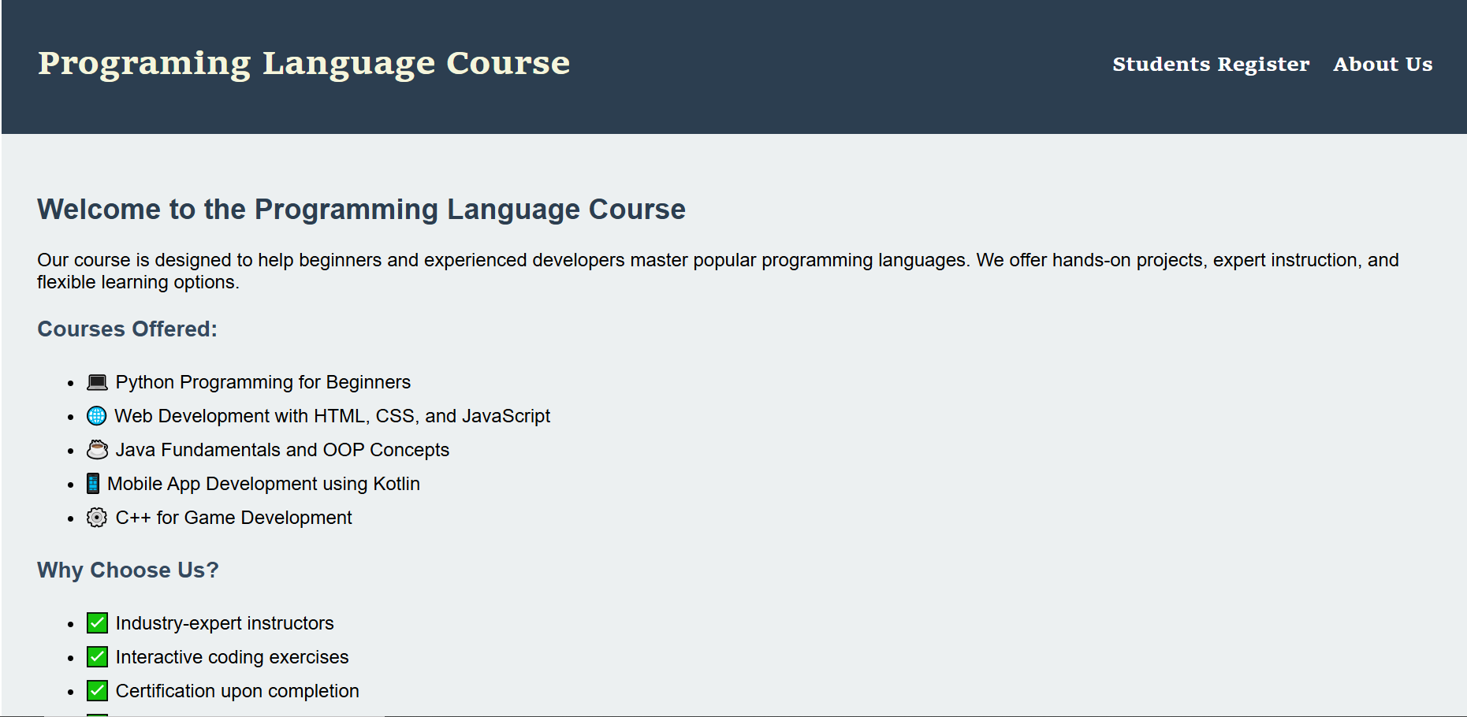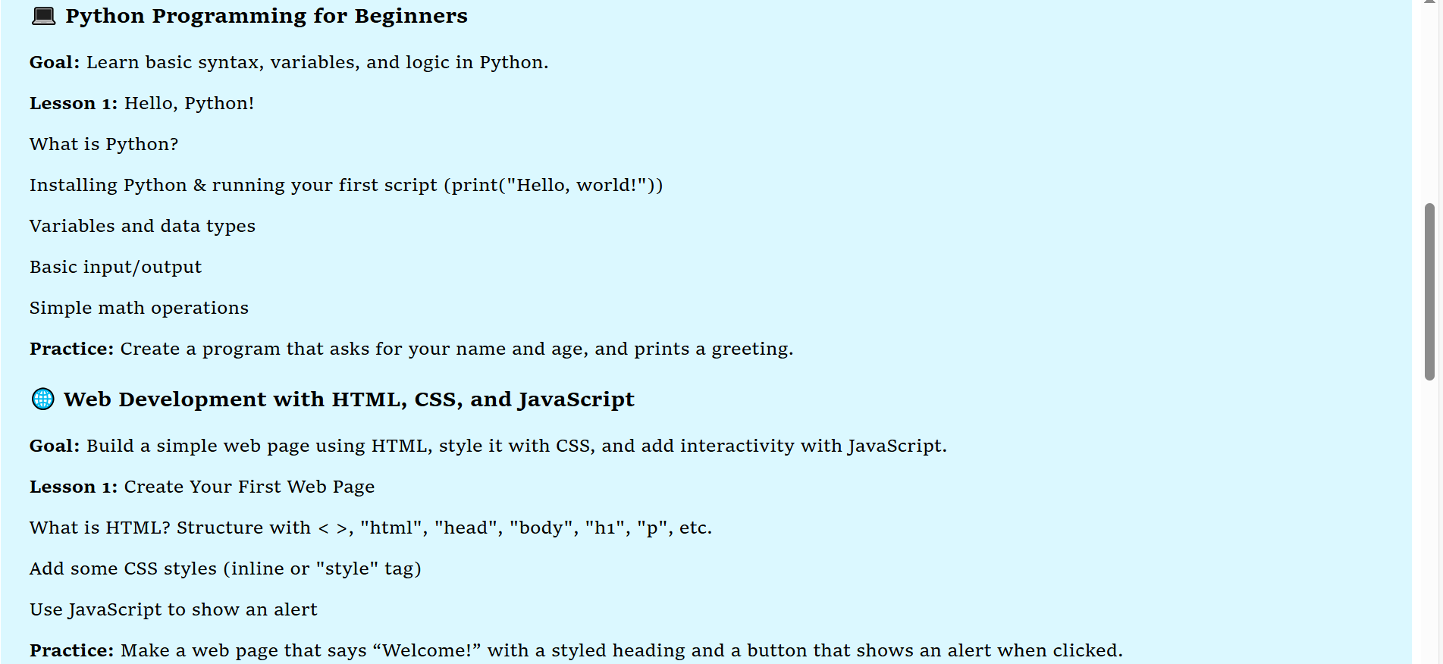

Online Course Management System - User Dashboard

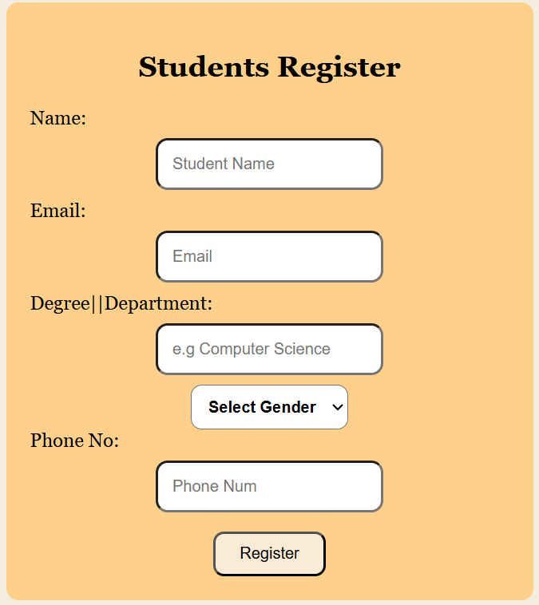

Students Registration Form

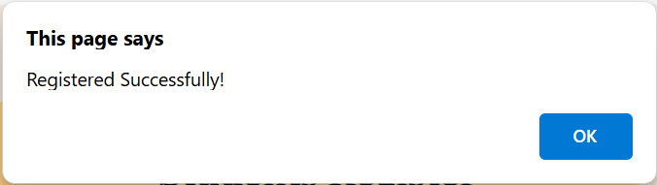

Successful Registration Pop-Up

## 5. CONCLUSION

## The Online Course Management System is a robust, user-friendly platform designed to streamline the entire process of course registration, student management, and course content delivery. By replacing traditional manual systems, it allows students to easily browse available courses, register, and track their progress in real-time, while offering administrators a centralized control panel to manage course offerings, registrations, and track student performance efficiently.

## With a user-centric design, the system provides a seamless experience for both students and administrators. Students can apply for courses, access course materials, and monitor their progress through a structured and intuitive interface, while administrators can manage course data, view student registrations, and generate performance reports. The application of role-based access control ensures that each user only accesses the functionality pertinent to their role, enhancing both security and efficiency.

## The system is developed using modern technologies like HTML, CSS, and JavaScript, ensuring cross-platform compatibility and responsiveness across various devices. Its modular architecture allows for easy future enhancements, such as integrating advanced features like virtual classrooms, grading automation, and certifications, making it a scalable solution for educational institutions of all sizes.

## By automating key processes like course registration, student management, and progress tracking, the Online Course Management System significantly reduces administrative overhead, improves operational efficiency, and enhances the overall learning experience. The system’s focus on transparency and real-time updates fosters improved communication between students and administrators, ensuring a smooth educational journey for all stakeholders.

## 6. BIBLIOGRAPHY

1. OpenAI: "GPT-3: Language Models for Text Generation." https://[www.openai.com](http://www.openai.com/)
2. GeeksforGeeks: "Computer Science Portal." [https://www.geeksforgeeks.org](https://www.geeksforgeeks.org/)
3. YouTube: “Various Tutorials and Educational Content." https://[www.youtube.com](http://www.youtube.com/)